Supplementary Table 1. Breakdown of target facilities.
 |  |  | Number of facilities |  | (%)
Facility type and perinatal center designation
 | Perinatal centers |  | 109 |  | (29.0%)
 |  | Comprehensive perinatal maternal and child medical centers |  | 32
 |  | Regional perinatal maternal and child medical centers |  | 77
 | Hospitals other than centers |  | 129 |  | (34.3%)
 | Clinics |  | 138 |  | (36.7%)
Region
 | Hokkaido |  | 31 |  | (8.2%)
 | Tohoku |  | 33 |  | (8.8%)
 | Kanto |  | 101 |  | (26.9%)
 | Chubu |  | 77 |  | (20.5%)
 | Kansai |  | 52 |  | (13.8%)
 | Chugoku |  | 25 |  | (6.6%)
 | Shikoku |  | 8 |  | (2.1%)
 | Kyushu/Okinawa |  | 49 |  | (13.0%)
Region classification by COVID-19 pandemic
 | High |  | 78 |  | (20.7%)
 | Middle |  | 114 |  | (30.4%)
 | Low |  | 184 |  | (48.9%)

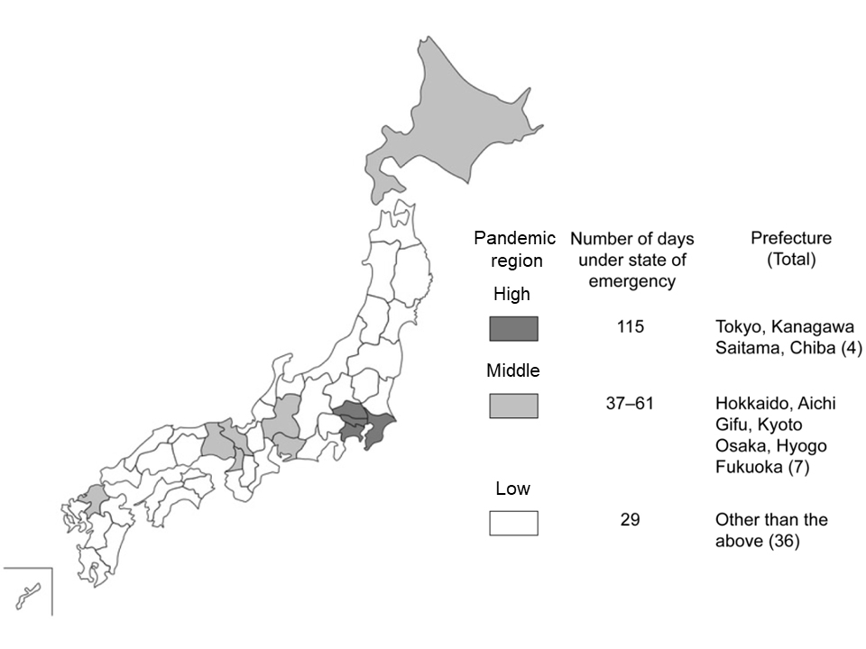
Supplementary Fig. 1.

